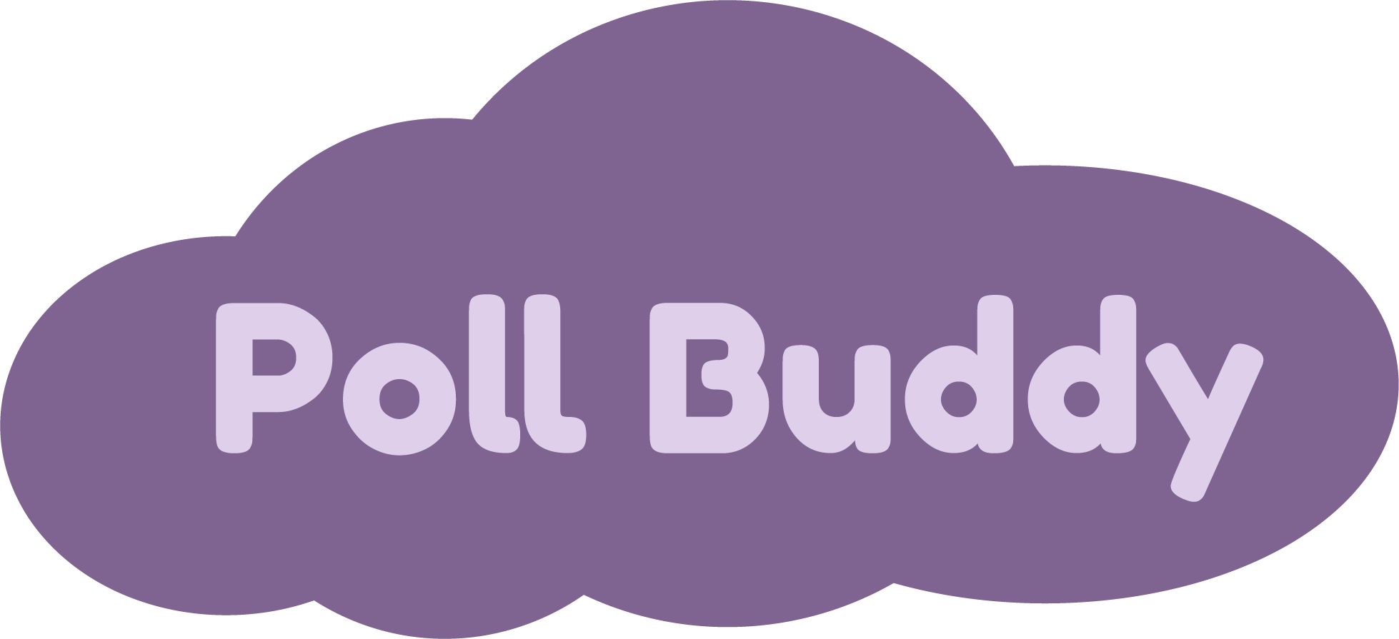

**Introduction:**

* Many professors use iClickers to ask questions or polls to their students.
* However, iClickers are expensive, bulky, outdated, easy to forget, difficult to integrate with other programs, and only professors can track answers.
* Therefore, we decided to create a website that has similar, yet improved functionality of iClickers, called **Poll Buddy**.
* Poll Buddy is a website that professors can use to interact with students during class. Professors will log in to their Poll Buddy account and will be able to create questions. Students will be able to log in to their accounts where they will be able to see the answer options and will be able to get Poll Buddy points for answering them. Both professors and students will be able to see question results and other statistics. Students will be able to view their Poll Buddy points at any time.

**Languages:** *Frontend*: HTML, CSS, JavaScript, React

*Backend*: NodeJS, MongoDB, Express, Docker

**Current Status:**

* Most frontend pages have been designed and are mid-implementation in code.
* The site’s backend, responsible for handling tasks like application logic and database interactions, has a large portion of functionality complete.
* A single logo, color scheme, and style guide has been created and is in the process of being implemented across all frontend pages.
* Overall, however, there is still much more work to do on the frontend before Poll Buddy can enter trials for deployment and in-classroom use. The development milestones for this semester reflect this.
* Most prevalent of these is the need for client-server communication, as the site offers no functionality to the average user without this.

**Development Milestones:**

* By the end of the 2020 summer semester, the team hopes to have evolved Poll Buddy to a state where it can begin seeing real-world use. Such a state is one that accomplishes the project’s goals laid out in the introduction.
* The development milestones outlined below detail some of the steps to be taken to reach this state. The project will still need to be worked on in future semesters to refine and tailor it to the needs and feedback from students and professors.
* End of June:
  + Proposal
  + Get everyone up to speed on the repo, tools, etc.
  + Some CI/CD and Github Actions
  + Sitemap/URL Scheme
  + CSS unification
* End of July:
  + Continued visual page construction
  + More client-server communication and page functionality
  + Assumed backend bugfixes during integration
  + Further CI/CD work
  + Cleanups
* End of August
  + Have the majority of pages looking and functioning as expected
  + Testing all functionality
  + Live version at [pollbuddy.app](https://pollbuddy.app)
  + ~~Take over~~ Change the world!

**Team Members:**

Poll Buddy **Hunter Harris** [**harrih3@rpi.edu**](mailto:harrih3@rpi.edu) **(PM)**

Poll Buddy **Neha Deshpande** [**deshpn2@rpi.edu**](mailto:deshpn2@rpi.edu)

Poll Buddy **Shweta Burgula** [**burgus@rpi.edu**](mailto:burgus@rpi.edu)

Poll Buddy **Annie Shi** [**shia@rpi.edu**](mailto:shia@rpi.edu)

Poll Buddy **Sam Schantz** [**schans2@rpi.edu**](mailto:schans2@rpi.edu)

Poll Buddy **Jason Pu** [**put@rpi.edu**](mailto:put@rpi.edu)

Poll Buddy **Andrew Emanuel** [**emanua2@rpi.edu**](mailto:emanua2@rpi.edu)

Poll Buddy **Jiarui Ruan** [**ruanj4@rpi.edu**](mailto:ruanj4@rpi.edu)

Poll Buddy **Andrew Fang** [**fanga2@rpi.edu**](mailto:fanga2@rpi.edu)

Poll Buddy **Julia Huang** [**huangs8@rpi.edu**](mailto:huangs8@rpi.edu)